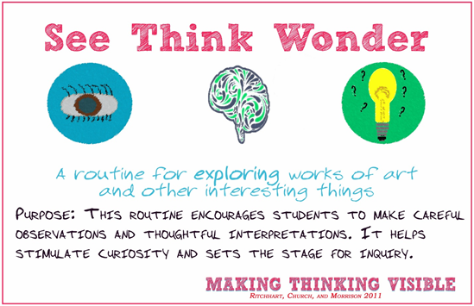These two pages are resources you can use from home with your Chromebook (2-5) or another device you may have at home. Use these sights with your parent’s permission and supervision.

**See, Think, Wonder:** use this method to discuss artwork you find online.

**1.  See** What do you see in the picture?

**2.  Think** What do you think is going on?

**3.  Wonder** What do you Wonder

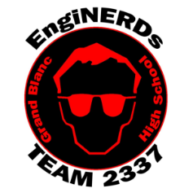

**Activity Pages from Jarrett Learner, the author of “EngiNerds”**

[Jarrett Lerner.com/activities](https://jarrettlerner.com/activities/)



**Lunch Doodles with Mo Willems**

Hang out with Author/Illustrator Mo Willems every day. (Live at 1 p.m.)  Stories, drawings, activities, and answers Kid’s questions. 11 Vidoes available now!

<https://www.kennedy-center.org/education/mo-willems/>

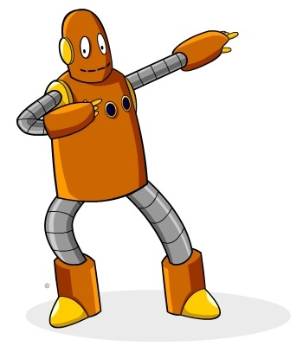

**BrainPOP and BrainPOP Jr**

Create a free 30 day account with your parents.

<https://www.brainpop.com/artsandmusic/> Grades K-12

<https://jr.brainpop.com/artsandtechnology/> Grades K-3

Use games, movie creator, code maker to study art concepts and famous artists.

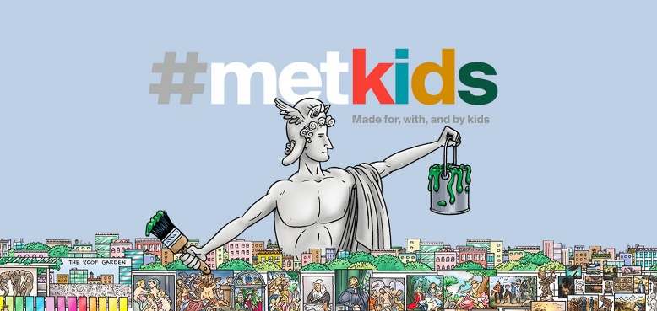**Met Kids**

<https://www.metmuseum.org/art/online-features/metkids/>

Explore the Metropolitan Museum of art with a Map, Time Machine and Videos

**Smithsonian Learning Lab**

**https://learninglab.si.edu/**

**Discover, Create, Share, Learn**



**Piskel (Grades 2-5)**  <https://www.piskelapp.com/>

Take advantage of your chromebook to create Amazing Pixel Artwork and Animation! Just use your google login!

**Art Hub for Kids**  (<https://www.youtube.com/user/ArtforKidsHub>

Draw along with a dad and his kids for a sprawling series of drawings for all ages!

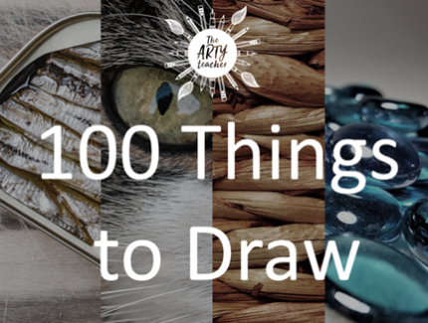

**What can I Draw** From the Arty Teacher:  A list of 100 ideas to draw. Use your imagination.

<https://theartyteacher.com/what-can-i-draw/>